KQ 380 Actual Cooktop w/o Beveled Edge (1.5” for Bevel)
Height of the warming shelf from the cooktop – 13.75”
Measuring underneath the warming shelf on the cooktop – 6.75”
Warming shelf top – 6.5”

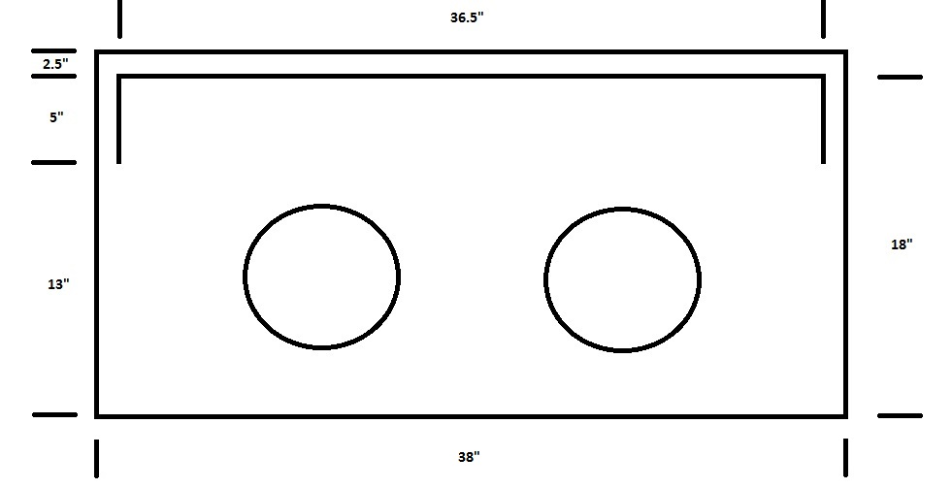

Leg Height – 9.5”
Leg to Leg Depth – 19.5”
Body Depth – 20”
Leg to Leg Width – 35”
Body Width – 36.5”
Overall Stove Height (to the top of the warming shelf) – 51.25”
Floor to Cooktop – 32”
Back of Flue to center – 3.75”

KQ 480 Actual Cooktop w/o Beveled Edge (1.5” for Bevel)
Height of the warming shelf from the cooktop – 14.75”
Measuring underneath the warming shelf on the cooktop – 8.75”
Warming shelf top – 8.5”

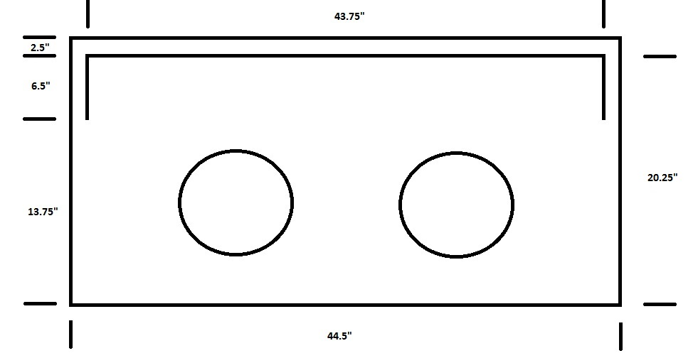

Leg Height – 10”
Leg to Leg Depth – 21.75”
Body Depth – 22.75”
Leg to Leg Width – 43”
Body Width – 45.5”
Overall Stove Height (to the top of the warming shelf) – 55”
Floor to Cooktop – 34.5”
Back of Flue to center – 4”

